5.Write a C program to check whether a given string belongs to the language defined by a Context Free Grammar (CFG)

S → 0S0 | A A → 1A | ε

Algorithm:

Certainly! Here's the algorithm for the provided C code:

1. Input:

- Declare a character array `s` to store the input string.

- Declare variables `i`, `flag`, `flag1`, `a`, `b`, `l`, `count1`, and `count2`.

2. User Input:

- Prompt the user to enter a string.

- Read the string using `scanf`.

3. Check Validity:

- Find the length of the input string using `strlen`.

- Initialize `flag` to 1.

- Iterate through each character of the string:

- If a character is not '0' or '1', set `flag` to 0.

- If `flag` is not 1, print "string is Not Valid."

4. Check Conditions 0n1m0n:

- If `flag` is 1:

- Initialize `i` and `count1` to 0.

- While `s[i]` is '0', increment `count1` and `i`.

- While `s[i]` is '1', increment `i`.

- Initialize `flag1` to 1 and `count2` to 0.

- While `i` is less than the length of the string:

- If `s[i]` is '0', increment `count2`.

- If `s[i]` is not '0', set `flag1` to 0.

- Increment `i`.

- Check the conditions:

- If `flag1` is 1 and `count1` is equal to `count2`, print "The string satisfies the condition 0n1m0n" and "String Accepted."

- If `flag1` is 0, print "The string does not satisfy the condition 0n1m0n" and "String Not Accepted."

5. Output

- Print the appropriate messages based on the conditions.

6. Return:

- Return 0 to indicate successful execution.

The code checks if the input string is valid and then verifies if it satisfies the condition "0^n1^m0^n," where n and m are the counts of '0' at the beginning and end, respectively, and '1' in between. The program outputs whether the string is accepted or not based on these conditions.

Program:

#include<stdio.h>

#include<string.h>

int main()

{

char s[100];

int i,flag,flag1,a,b;

int l,count1,count2;

printf("enter a string to check:");

scanf("%s",s);

l=strlen(s);

flag=1;

for(i=0;i<l;i++)

{

if(s[i]!='0' && s[i]!='1')

{

flag=0;

}

}

if(flag!=1)

printf("string is Not Valid\n");

if(flag==1)

{

i=0;count1=0;

while(s[i]=='0') // Count the no of 0s in the front

{

count1++;

i++;

}

while(s[i]=='1')

{

i++; // Skip all 1s

}

flag1=1;

count2=0;

while(i<l)

{

if(s[i]=='0')// Count the no of 0s at the end

{

count2++;

}

else

{

flag1=0;

}

i++;

}

if(flag1==1)

{

if(count1==count2)

{

printf("The string satisfies the condition 0n1m0n\n");

printf("String Accepted\n");

}

else

{

printf("The string does not satisfy the condition 0n1m0n\n");

printf("String Not Accepted\n");

}

}

else

{

printf("The string does not satisfy the condition 0n1m0n\n");

printf("String Not Accepted\n");

}

}

return 0;

}

Output 1:

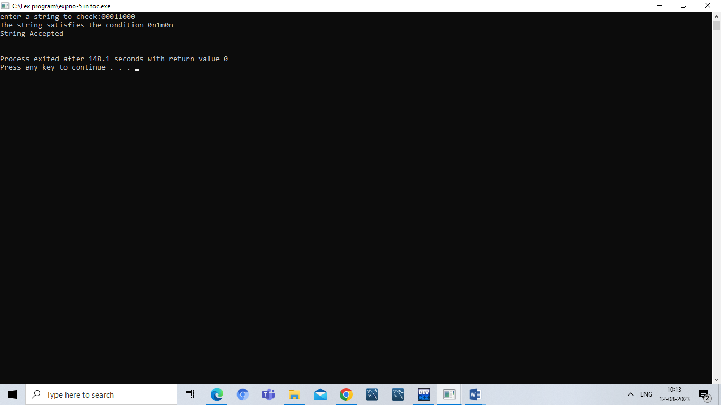

Output:

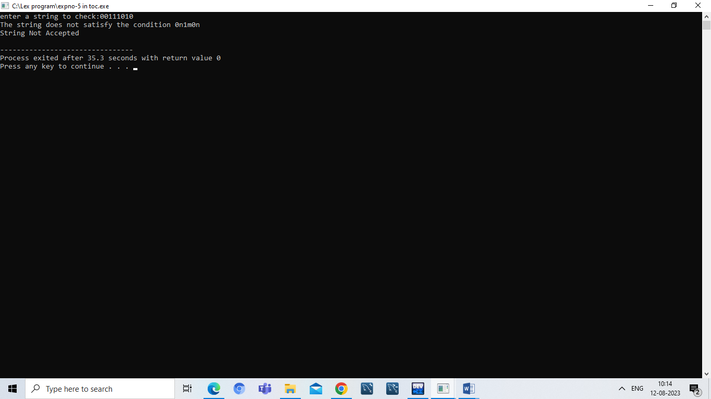

Result:

Hence ,we successfully compiled the c program for CFG.